**CSSE1001: 2018 S2 Exam**

[**UQAttic**](http://uqattic.net)

[**Other exam papers**](https://drive.google.com/open?id=0B_gnBD5zp3rqT2hrLWhvd2Rkc1U)

Please **contribute** to these documents.

If you're looking for an effective way to familiarise yourself with the course material, you can't go past collaborating with fellow students. We have laboured to put these up, and so at the very least point out where you think we are wrong!

You'll get more out of the course, you'll do better in the exam, and other students will benefit from your input as well.

To get editing permissions, visit [UQAttic.net](http://uqattic.net) and provide us with your Google Account address.

**Style.**

Type answers in blue beneath each question.

If you're unsure of your answer, highlight your answer text then hit Ctrl+Alt+M to create a comment beside the text. Once you're satisfied with the answer, click the "Resolve" button on the comment.

If you want some extra explanation from someone else on their answer, highlight the other person's answer and repeat the procedure above.

Feel free to contribute, ask questions and provide explanations and proofs.

If you have doubts about the answers, please **discuss** first before directly modifying them.

1. B

2. A

3. B - 3**2 = 9, 9 % 4 is 1 (1 remainder after dividing by 4 since 8%4=0)

4. D - (What’s wrong with the expression? Thanks.) → hard to explain, just like a general rule, you can use 3*”a” get “aaa”, whereas you cannot get “a” through “aaa”/3 -- So 4* “fox” is correct but we cannot use “/4”? Yes hi :) -- Thx

5. C - (make sure you put the list() function when you test it.)

6. C

7. E

8. B

9. E - (How to get this answer?thanks!) ---> b and d could get the right answer (agree)

10. B

11. D - Input returns strings and you can not divide strings with each other

12. C

13. C - z will be split on white space (which includes new lines) *.split* returns the list: [“one”, “life]. sorted() will sort those two words based on alphabetical order (hence ‘life’ before ‘one’)

14. A - (why?) (+= go to global and normal form like x=x+[2] go to local)thx - cheers (And how about the value of ‘a’?) i see you typing :) - :D Actually, += can not make an int or str global. it is only useful for lists.

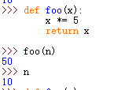

A is right, check by python visualize

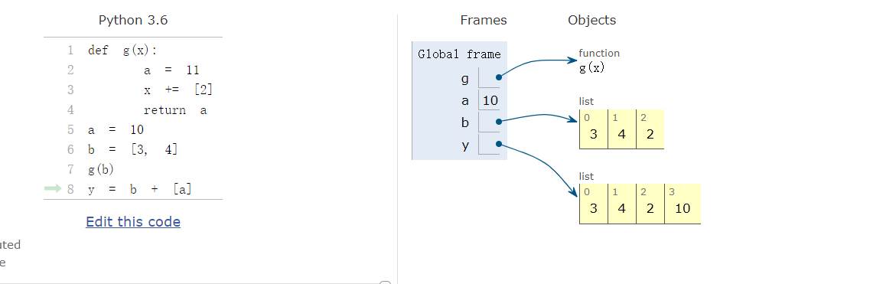

Can anyone explain WHY b gets reassigned within the function to global?

15. D - When the function is called, v=x, u = 2, b = 3. v.pop(u) will remove the 2nd element from the list v. v is now [2,3],b is then added to the end of v, which is 3, making v [2,3,3]. The function returns v.

within a function changes the global variable (and the local variable), whereas v = v + [b] only changes the local variable. So if it were v += [b] inside the function f, the end answer would be [2, 3, 3, 2, 3, 3] instead of the [2, 3, 3, 2, 3] that you get with v = v + [b]

There is nothing to do with global variables in this question. This question looks at modifying lists. Aka always ask yourself when answering these styles of questions “does this make a new list or just modify the old one?”

1. Passing x into the function f, passes the reference of the list. Aka there is 1 list in memory. So if you modify v, you also modify x.
2. v.pop(u) modifies v, and hence x. This does not create a new list. Just modifies the existing one in memory

At this point in time:

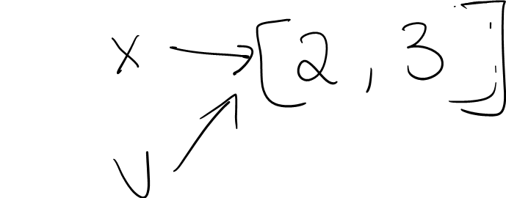

1. v = v + [b] creates a second list in memory. Remember we read stuff to the right of the equals sign first.
2. So therefore: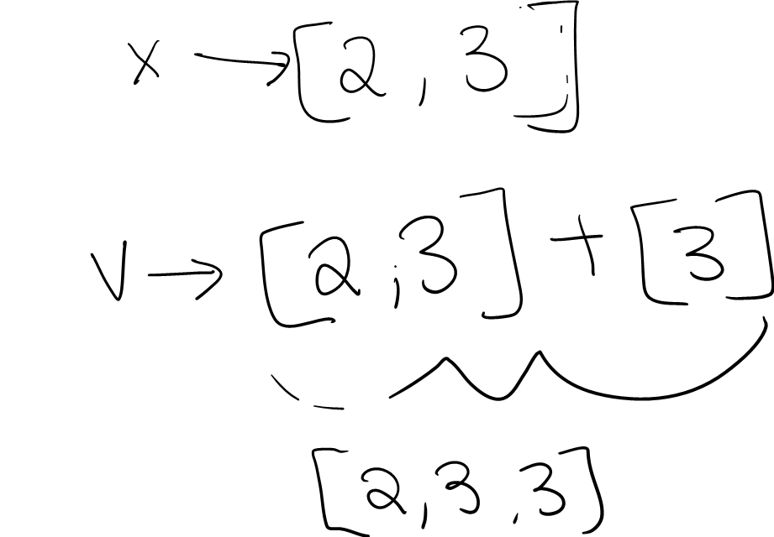

Please note there are 2 lists in memory. If we change v, we do not change x.

1. We return v and go x = f(x, 2, 3) + x

f(x, 2, 3) gave us [2,3,3]

Therefore x = [2,3,3] + [2,3]

= [2, 3, 3, 2, 3]

(Great work)

16. B

17. B - You would get {} in the beginning. And the key does not exist in {}, so finally get [].

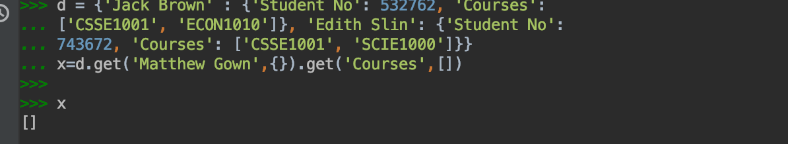

18. C - (why not B) - append do not return e.g. y=[‘aaa’,’bbb’] x=y.append(‘xx’)-->None Cause append returns None

19. D - (why not b???, i tried running the function and it is in an infinite loop) Try inputting 0 in does it stop the loop?? Yes thanks misread that bit

20. C - (how does this work, i dont understand how the 4 comes by). [1, 2, 2, 1, 4] is the initial list, 1 is not equal to 5 so we take x[2:] which is 2 till the end which is [2,1,4] and add x[0] which is 1 so [2,1,4,1]. Then, 2 is not equal to 4 so take x[2:] which is [4,1] and add x[0] which is 2 so we end up with [4,1,2]. Then 4 is not equal to 3, take x[2:] again which is 2 and add x[0] which is 4 which we end up with [2,4]. Now 2 equals to 2 (if statement, length and first element) so return. Gud? So basically the function will keep running till it matches ? gotcha thx! Yis yis dont lose hope keep going till something feels really bad. (if loop)

21. D

22. B - ( can someone explain how to get this answer?)

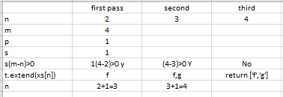

23. E - The value of m-n for this question equates to 4 therefore there should be 4 positions after the ‘f’ v ue

24. A - (can somebody explain this please?) s = 2/abs(2) = 1. 1*(-4--1) = -3 which is less than 0 (the function runs while this value is greater than 0) so the function returns t which is [ ].

25. A

26. C

27. D - ( how about answer a? Why we can’t print the answer? Is that because we should save the value) ---> In deposit method, you have changed the balance account, thus, here, you just need to help user to get the newest balance account. In my view, generally, you do not need print, once user call the function, they can get the value.

28. A - For this question you can rule out a few answers, you can tell that b would be wrong since the deposit function needs to have an amount value so it would return an error. D +would be wrong since you cannot have an amount that equates to an object therefore returning an error. C would also be incorrect since python does not know where the function deposit comes from (This is also another reason why D does not work).

29. B - can anyone explain why(29 and 30)? text.find(‘a’, start) will find a in text from the position start given and return a’s p osition (or -1 if a isnt in the text I think). .split(‘“‘, 2) then splits at “ 2 times giving a list of three strings split by two “ and you want the middle string [1] since that’s what is in between the two “. what does [next_pos:] mean ? That is an index value. On entering the while loop next_pos = 17, so text[next_pos:] becomes text[17:]

30. B - not a?

31. C - can anyone explain why e is wrong? E is incorrect because the starting index that you would be starting with would be at whatever next_pos was originally was before the while loop since no other line before hand altered next_pos. Therefore, if you are doing a find function with the same string that you’re looking for starting at the same exact position as before the while loop you will end up finding the same exact <a href position. That is why C is correct since you start at the start_tag which is where </a> normally happens (underlined where it would start the find function)

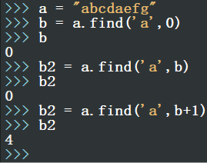

32. A

33. C - Can someone explain why not D? For this question, you are calling the a1 function of b. Since the B class does not have an a1 you look at its super class, which does have one. The inputs of a1 are (1,1) therefore A.a1 would return self.a 2(1,1) + 3. Since self is the B class you call the a2 function in B. By doing B.a2(1,1) you should get 1 + 2*1 = 3 so therefore 3 + 3 = 6.

34. C - So why Q34 choose C ? I’m confused about how to understand self.

_x and self._y For Q34 self._x and self._y are defined in the __init__ method of the C class, where self._x = x and self._y = 2*y+x. Remember that these x and y values are from the __init__(self, x, y) part. If the C class did not have a self._x or self._y variables they cannot be called upon. So since c.a1(2,2) and c = C(2,1) where 2, 1 are x and y of the C class you should be able to see that the inputs 2,2 do not do anything in the c.a1 method since it isn’t

x + y. Therefore, self._x = the x value of the C input which is 2 and self._y = 2*1 + 2 = 4, so 2+4 = 6 which is C. I recommend watching the revision session where they covered these questions.

35. B

36. C - bit confused by this question? d.a2() calls super().a2(), which is the a2 method from D’s parent class B. d.a2(2, 1) passes 2 and 1 to a2 method in class B, returning x + 2y => 4.

37. E - (both B and D are correct answers) ?????? why I have no idea :^) (Canvas has create_oval(..). So if ‘sel\f.create_oval’ cannot find create_oval from current class, then it will find this function in tk.Canvas. Also, super().create_oval(*args) can call the function from tk.Canvas with arguments *args )

38. D - (2019 question36 the answer was D why it’s different this time?) A method or function itself should be passed to command, not the return value. left() is calling left method and get a return, not what command wants.

39. B - If you read what it says above the question you can understand what the parameters are, so indexes is best explained in the text right above the question. The functions goal is to find the element in the ‘whatever-th list’ of the ‘whatever-th list’ etc. specified by index. B is the answer as it finds the list at the element (the “indexes[0]” part), this is passed as the new nested list and the first element of indexes is removed. This repeats until it finds the element at index. Essentially, it makes the nested list smaller each time specified by indexes.

40. D - (40 is not examinable????????) Yep tutor said in the revision session that it wouldn’t be examined this year. list

(

('a', 'c')

+ (1,2,))